Provision for children under 5 years of age in England, January 2019

National take up of funded early education remains high among 3- and 4-year-olds at 1,277,100
27 June 2019
Take up rates of funded early education for 3- and 4-year-olds stayed the same as in 2018. 92% of 3-year- olds, and 95% of 4-year-olds benefited from funded early education in January 2019 – a total of 1,277,100 children (compared with 1,284,632 in 2018).
91% of all 3- and 4-year-receiving funded early education attended a setting rated good or outstanding by Ofsted (see Section 5).
Lancashire take up of funded early education remains high among 3- and 4-year-olds at 27,019
Take up rates of funded early education for 3- and 4-year-olds increased on 2018. 97% of 3-year- olds, and 100% of 4-year-olds benefited from funded early education in January 2019 – a total of 27,019 children (compared with 27,270 in 2018).
94% of all 3- and 4-year-receiving funded early education attended a setting rated good or outstanding by Ofsted (see Section 5).
NB 32% of all 3- and 4-year-receiving funded early education attended a setting rated outstanding by Ofsted, compared with 27% nationally.
In Lancashire, over 9,000 children benefited from the extended funded early education, up 7%
Nationally, over 328,000 children benefited from the extended funded early education, up 11%

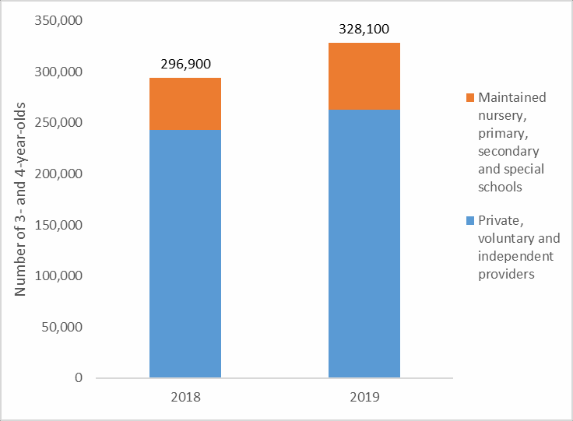 | Nationally, in January 2019, 328,100 3- and 4- year-old children benefited from the extended early entitlement (up to an additional 15 hours – meaning a total of up to 30 hours entitlement). This is an increase of 11% from 296,900 children in January 2018.  96% of all 3- and 4-year-olds benefiting from the extended entitlement attended a setting rated good or outstanding by Ofsted (see Section 5).  …………………………………………

In Lancashire, in January 2019, 9,274
3- and 4- year-old children benefited from the extended early entitlement. This is an increase of 7% from 8,680 children in January 2018.
97% of all 3- and 4-year-olds benefiting from the
extended entitlement attended a setting rated good or outstanding by Ofsted.
NB 37% of all 3- and 4-year-olds benefiting from the extended entitlement attended a setting rated outstanding by Ofsted, compared with 29% nationally.

Take up rate for eligible 2-year-olds decreases to 68% nationally- and to 69% in Lancashire.
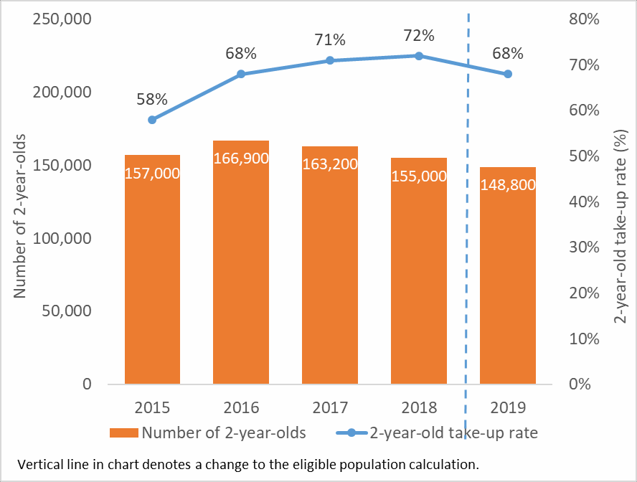 | Nationally, the number of 2-year-olds benefiting from funded early education decreased by 6,200 to 148,800 in January 2019.  The take-up rate has decreased from 72% to 68% in 2019. This is mainly due to fewer children benefiting from the entitlement, but has also been partly affected by a change in the calculation of the eligible population. The vertical line in the chart represents this change in calculation.  96% of all 2-year-olds receiving funded early education attended a setting rated good or outstanding by Ofsted (see Section 5).  In Lancashire, the number of 2-year-olds benefiting from funded early education decreased by 17 to 3,243 in January 2019. The take-up rate has decreased from 75% to 69% in 2019 (see note above).  99% of all 2-year-olds receiving funded early education attended a setting rated good or outstanding by Ofsted.  NB 39% of all 2-year-olds receiving funded early education attended a setting rated outstanding by Ofsted, compared with 24% nationally.
The percentage of 2-, 3- and 4- year old children benefiting from funded early education at private, voluntary and independent providers with staff with graduate statuses is high

This detail is not included in the main report but is included in the accompanying tables. The percentage of 2-, 3- and 4- year old children benefiting from funded early education at private, voluntary and independent providers with staff with graduate statuses is 65%, compared with 52% nationally.
The percentage of private, voluntary and independent providers with staff with graduate statuses is 41%, compared with 36% nationally.
…………………………………………………………………………………………………………………………
All of the headline data figures contained within this statistical first release better than national figures.
In summary, Lancashire's nursery take up rates and the quality of the provision is better than that found nationally for all ages of children and provider types. Furthermore, the key data is better overall than that of Lancashire's highest performing statistical neighbor (as measured by the Early Years Foundation Stage Profile data).

The desire to maintain or improve quality and take up is a given and the focus is on sustainability.

Contents
Numbers benefiting from funded early education 4
Number of eligible 2-year-olds 4
Number of 3- and 4-year-olds 5
Numbers benefiting from extended early education 6
Provider types 6
2-year-olds by provider type 6
Funded early education for 3-and 4-year-olds by provider type 6
Extended early education for 3- and 4-year-olds by provider type 7
Number of providers 8
Number benefiting by Ofsted inspection rating 10
Accompanying tables 10
Further information is available 12
National Statistics 12
Technical information 12
Get in touch 13
Media enquiries 13
Other enquiries/feedback 13

About this release
This statistics publication contains the latest information for January 2019 on provision of funded early education for children under 5 in the maintained, private, voluntary and independent sectors in England, together with figures for earlier years. The data was collected from schools, maintained nurseries, local authorities and private, voluntary and independent providers (PVIs) in January 2019 as part of the early years census, spring school census and the school level annual school census (for general hospital schools).
Figures in the main tables are provided unrounded, however, they are rounded to the nearest 100 in this commentary document for ease of presentation.

In this publication
The following tables are included in the statistics publication:
- Main tables (Excel .xls)
- Underlying data (open format .csv and metadata .txt)
The accompanying technical document, provides information on the data sources, their coverage and quality and explains the methodology used in producing the data.

Feedback
We are changing how our releases look and welcome feedback on any aspect of this document at EarlyYears.STATISTICS@education.gov.uk

Numbers benefiting from funded early education (Tables 1, 2, 4 and 6)
Eligibility for funded early education
All 4-year-olds have been entitled to a funded early education place since 1998 and in 2004 this was extended to all 3- year-olds. Since September 2010, all 3- and 4-year-olds have been entitled to 570 hours a year of funded early education over no fewer than 38 weeks of the year (which equates to 15 hours a week for 38 weeks of the year). This is known as the universal entitlement and is referred to in this publication as funded early education.
From September 2013, the entitlement to 15 hours of funded early education per week for 38 weeks of the year was extended to 2-year-olds who met certain eligibility criteria and from September 2014, it was further extended to more 2-year-olds who met other eligibility criteria. In April 2018 the eligibility criteria changed to reflect the introduction of universal credit.
In September 2017, the government doubled the funded early education entitlement for 3- and 4-year-olds from working families who meet the eligibility criteria to 30 hours a week for 38 weeks of the year (or 1,140 hours a year over no fewer than 38 weeks of the year). This is referred to in this publication as extended funded early education.
Further information about the early education entitlements can be found within the accompanying technical document.

Numbers benefiting from funded early education
Where they are receiving funded early education at more than one private, voluntary or independent provider, children have only been counted once at the provider where they take the majority of their funded hours.
A child splitting their funded hours between a maintained school and a private, voluntary or independent provider may be counted more than once. This does not impact the national take up rates.
For 3- and 4-year-olds, the eligible population used to calculate take-up rates is the ONS population estimate. For 2- year-olds, take-up rates are expressed as a percentage of the estimated eligible population. This is the fifth time they have been based upon data from the Department for Work and Pensions. However, for 2019 the estimated eligible population data includes Universal Credit Full Service claimants for the first time. For further information see the accompanying technical document.

Number of eligible 2-year-olds

National
In January 2019, 68% of the eligible 2-year-old population benefited from some funded early education, down from 72% in 2018. The number of children benefiting decreased from 155,000 in 2018 to 148,800 in 2019.
The eligible population figures increased in 2019 and included Universal Credit Full Service claimants for the first time. This has resulted in the addition of 32,900 children of Universal Credit Full Service claimants to the eligible population data. For further information see the accompanying technical document.
The 2-year-old take-up rate using the number of children benefiting in January 2019 as a proportion of the eligible population used in 2018 statistics release (which excluded Universal Credit Full Service claimants) is 69%. This suggests the main driver for the drop in the take-up rate is the decrease in the number of children benefiting, rather than the addition of Universal Credit Full Service claimants to the eligible population data.

Lancashire
In January 2019, 69% of the eligible 2-year-old population benefited from some funded early education, down from 75% in 2018. The number of children benefiting decreased from 3,260 in 2018 to 3,243 in 2019.

Number of 3- and 4-year-olds
Population data
The ONS population estimates for 2017 and 2018 used in this publication have been revised, therefore take up rates for these years may differ to those previously published. For further information, see the accompanying technical document.

National
In January 2019, 94% of the 3- and 4-year-old population benefited from some funded early education, the same as last year. However, the number decreased by 7,500 from January 2018 to 1,277,100.
92% of the 3-year-old population, and 95% of the 4-year-old population benefited from some funded early education, each showing little change from January 2018.

Lancashire
In January 2019, 99% of the 3- and 4-year-old population benefited from some funded early education, a percentage point above last year. However, the number decreased by 251 from January 2018 to
27,019.

97% of the 3-year-old population (up by 1% on January 2018), and 100% of the 4-year-old population benefitted from some funded early education (as a year ago).

Figure A: Number and percentage of 3- and 4-year-olds benefiting from funded early education, 2011 to 2019
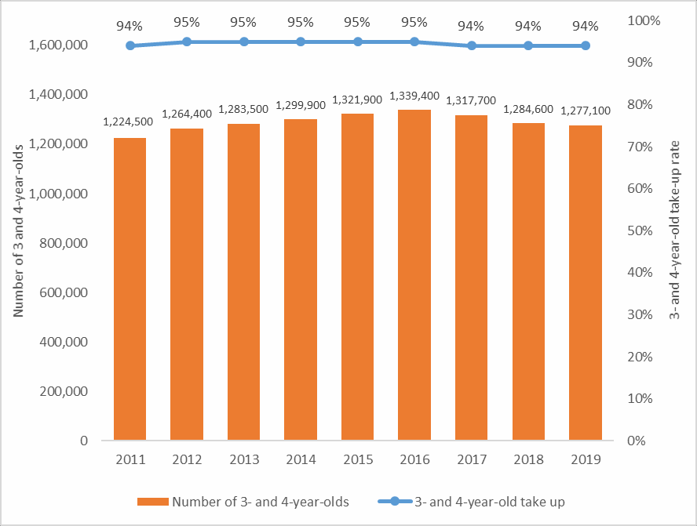

Numbers benefiting from extended early education (Tables 3LA, 5LA & 7LA)
Data sources on the extended early entitlement
Since the introduction of the extended early education entitlement policy in September 2017, the Department for Education has published regular management information to monitor the policy. These consist of monthly management information on the number of eligibility codes issued and validated, and termly headcounts of the number of children in a 30-hour place. While spring term 2019 headcount data (published in March 2019) was based on the same census date as both the January 2019 early years census and schools census, the figures will not align exactly as many LAs were still in the process of finalising and refining their figures when they submitted their headcount data.
This statistics publication gives a definitive picture of the number of children in a 30 hours place in January 2019, along with breakdowns by provider type, Ofsted rating of provider, special educational needs provision and staff qualifications.

National
In January 2019, 328,100 3- and 4-year-old children benefited from extended early education, an increase of 11% since 2018. We would expect to see variation across years as the number of eligible children will change depending on the birth cohort and parental employment.
Estimates suggest around 410,000 children were eligible for the extended hours nationally, meaning around 4 out of 5 eligible children have taken up some extended hours. Further information on the eligibility estimate can be found in the accompanying technical document.

Lancashire

In January 2019, 329,274 3- and 4-year-old children benefited from extended early education, an increase of 7% since 2018.

Provider types (Tables 12 to 14)

Funded early education for 2-year-olds by provider type
The proportion of 2-year-olds accessing their free entitlement in maintained nursery, primary, secondary and special schools has increased from a very low base since data was first collected in 2014 (See Figure B), whilst the percentage in private, voluntary and independent providers (including childminders) has decreased.
Two factors are likely to have contributed to this increase in the maintained sector; the Small Business Enterprise and Employment Act coming into force in 2015 and clearer guidance for local authorities on whether children should be returned on the early years or school census. Further information can be found in the accompanying technical document.
https://assets.publishing.service.gov.uk/government/uploads/system/uploads/attachment_data/file/811642/Provision_for_children_under_5_2019_-_technical_document.pdf

Funded early education for 3-and 4-year-olds by provider type
The majority of 3-year-olds access their funded early education in private, voluntary and independent providers (including childminders). The proportion attending maintained nursery, primary, secondary and special schools has decreased slightly over the last 5 years.
The proportional split of 4-year-olds across provider types has remained broadly similar in recent years with the majority accessing their funded early education in infant classes in primary schools (i.e. reception classes).

Lancashire

Funded early education for 2-year-olds by provider type
The proportion of 2-year-olds accessing their free entitlement in maintained nursery, primary, secondary and special schools has increased from a very low base since data was first collected in 2014 whilst the percentage in private, voluntary and independent providers (including childminders) has decreased.

Funded early education for 3-and 4-year-olds by provider type
The majority of 3-year-olds access their funded early education in private, voluntary and independent providers (including childminders). The proportion attending maintained nursery, primary, secondary and special schools has been consistent over the last 5 years, with the exception of last year when it dropped to 15%.
The proportional split of 4-year-olds across provider types has remained broadly similar in recent years with the majority accessing their funded early education in infant classes in primary schools (i.e. reception classes).

Figure B: Percentage of 2-, 3- and 4-year-old children benefiting from funded early education by provider type, 2014 to 2019
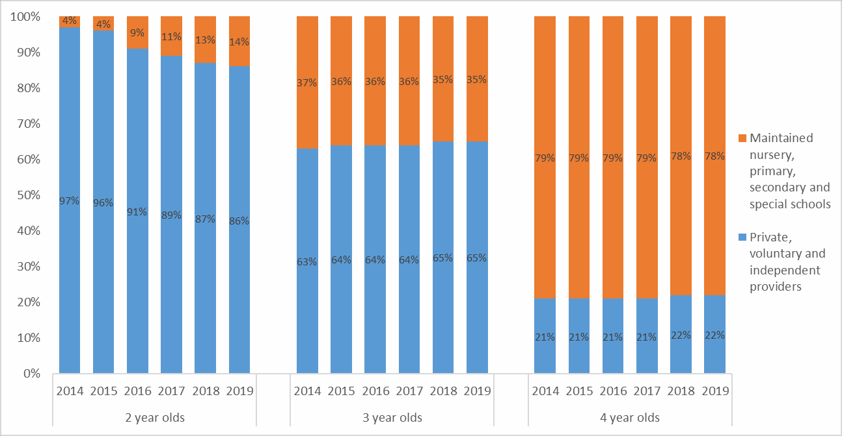
Percentages are rounded to the nearest whole number and may not sum to 100%.

Extended early education for 3- and 4-year-olds by provider type

National
Whilst the majority of extended early education was provided at private, voluntary and independent providers (including childminders), the proportion provided at maintained nursery, primary, secondary and special schools has increased since 2018 from 18% to 20%.
Evidence1 suggests in the first year of the extended entitlement, schools were offering the first 15 funded hours and private, voluntary and independent providers were providing the extended entitlement as wraparound care. The increase from 18% to 20% seen this year suggests schools are extending their provision to include the extended entitlement.

Lancashire
Whilst the majority of extended early education was provided at private, voluntary and independent providers (including childminders), the proportion provided at maintained nursery, primary, secondary and special schools has remained constant at 14%. There were 888 providers of extended early education in January 2019 compared with 861 providers a year ago. The increase is based on 51 more private and voluntary providers and 5 more maintained school providers of extended early education.

Figure C: Percentage of 3- and 4-year-old children benefiting from extended funded early education by provider type, 2018 to 2019
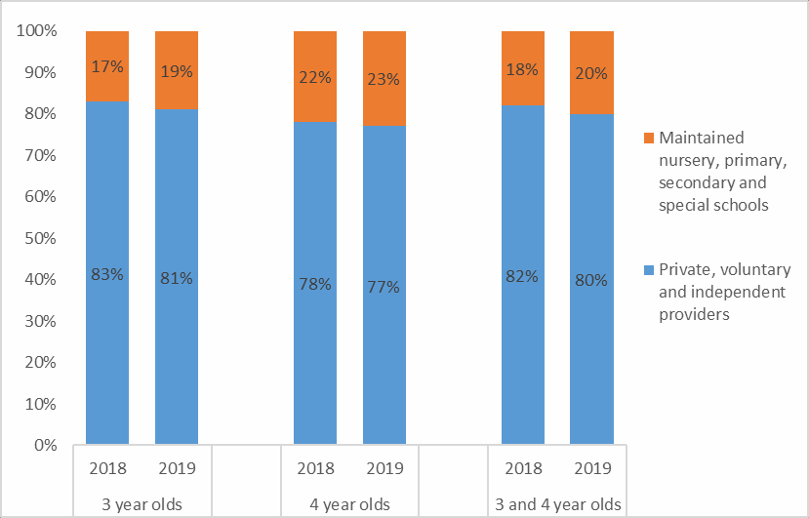
1 https://www.gov.uk/government/publications/30-hours-free-childcare-final-evaluation-of-the-national-rollout https://www.gov.uk/government/statistics/childcare-and-early-years-providers-survey-2018

Number of providers (Tables 12, 12LA, 13, 13LA, 14 and 14LA)
Data cleaning exercise for provider types
Since 2014 the number of providers coded as ‘other’ on the early years census has continued to increase. During the 2019 data collection period, DfE undertook a data cleaning exercise to improve data quality working with local authorities to re-code providers to the correct provider type. Caution should therefore be taken when comparing changes in provider types between 2019 and earlier years. Further information can be found in the accompanying technical document.
When a child splits their entitlement over more than one provider, the provider where they spend the majority of their time is counted. As childminders often provide wrap-around care, the count of childminders is under-reported by this methodology. Further information is available in the accompanying technical document.

National
For 2-year-olds, the total number of providers has shown a small decrease from 22,700 in 2018 to 22,600 in 2019.
48,100 providers delivered funded early education to 3- and 4-year-olds in January 2019, up 1% from 2018.
35,800 settings provided extended funded early education to 3- and 4-year-old children up by 5% compared with 2018.

Lancashire
For 2-year-olds, the total number of providers has shown a small increase from 542 in 2018 to 544 in 2019.
1,296 providers delivered funded early education to 3- and 4-year-olds in January 2019, up 0.5% from 2018.
888 settings provided extended funded early education to 3- and 4-year-old children up by 3% compared with 2018.

Number of providers by type of entitlement
The following supplementary analysis, not included in the tables, is based on all providers delivering the funded entitlements, therefore numbers will not match those above or published in Tables 12 to 14LA.
Of the 52,400 private, voluntary and independent providers, maintained nursery, primary, secondary and special schools delivering the funded early education entitlements to 3- and 4-year-olds, 63% delivered both funded early education (first 15 hours) and extended early education (additional 15 hours). This has increased from 60% in 2018. 30% delivered only the first 15 hours, and the remaining 7% delivered the extended entitlement only.
This varied by type of early years provider. 87% of private, voluntary and independent providers delivered both entitlements. 22% of childminders delivered the extended entitlement only compared with no maintained schools.

Figure D: Providers delivering funded early education by type of entitlement and provider type

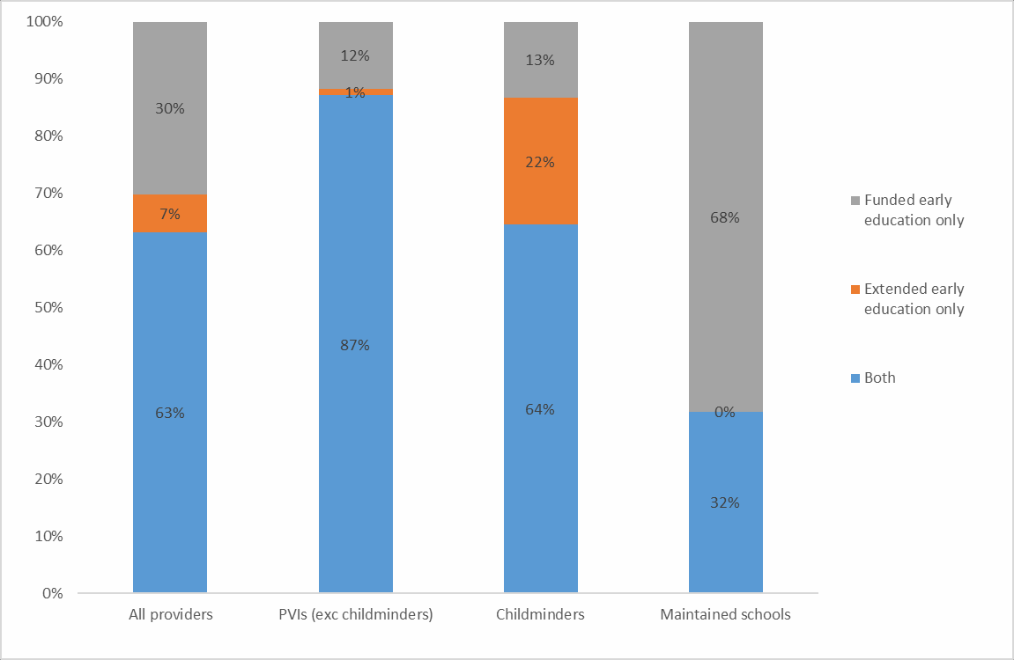

Number benefiting by Ofsted inspection rating (Tables 16LA & 17LA)
Numbers benefiting by Ofsted inspection rating
Matching Ofsted inspections data to both the early years census and school census enables local authorities to see whether they are getting value for money and monitor the quality of early years settings receiving government funding to deliver early education places. Percentages exclude providers where we made no match to an Ofsted inspection rating. Further information regarding matching process can be found within the accompanying technical document.

National
In January 2019, 96% of 2-year-olds and 91% of 3- and 4-year-olds benefiting from some funded early education attended a setting rated good or outstanding.
The comparable figure for 3- and 4-year-olds benefiting from extended early education was 96%.

Lancashire
In January 2019, 99% of 2-year-olds and 94% of 3- and 4-year-olds benefiting from some funded early education attended a setting rated good or outstanding.
NB 39% of all 2-year-olds receiving funded early education attended a setting rated outstanding by Ofsted, compared with 24% nationally.
32% of all 3- and 4-year-receiving funded early education attended a setting rated outstanding by Ofsted, compared with 27% nationally.

The comparable figure for 3- and 4-year-olds benefiting from extended early education was 97%.
NB 37% of all 3- and 4-year-olds benefiting from the extended entitlement attended a setting rated outstanding by Ofsted, compared with 29% nationally.

Figure E: Percentage of children benefiting from funded early education by Ofsted inspection rating, January 2019
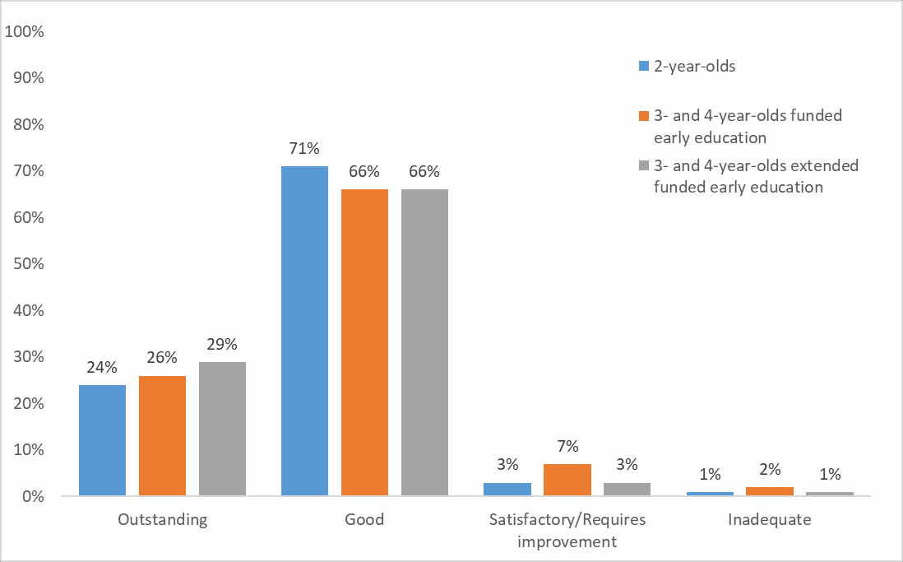

Accompanying tables
The following tables are available in Excel format on the department’s childcare and early year’s statistics website
National tables

1 | Number of 2-year-old children benefiting from funded early education places by type of provider
2 | Number of 3- and 4-year-old children benefiting from funded early education places by type of provider
3 | Number of 3- and 4-year-old children benefiting from extended funded early education places by type of provider
4 | Number of 3-year-old children benefiting from funded early education places by type of provider
5 | Number of 3-year-old children benefiting from extended funded early education places by type of provider
6 | Number of 4-year-old children benefiting from funded early education places by type of provider
7 | Number of 4-year-old children benefiting from extended funded early education places by type of provider
12 | Number of 2-year-olds benefiting from funded early education, in private, voluntary and independent providers, and in maintained nursery, primary, secondary and special schools by type of provider
13 | Number of 3- and 4-year-olds benefiting from funded early education, in private, voluntary and independent providers, and in maintained nursery, primary, secondary and special schools by type of provider
14 | Number of 3- and 4-year-olds benefiting from extended funded early education, in private, voluntary and independent providers, and in maintained nursery, primary, secondary and special schools by type of provider
20 | The basis on which 3- and 4-year-old children were recorded as in receipt of early years pupil premium
21 | Number and percentage of early years staff at private, voluntary and independent providers, by highest qualification and category of provider
22 | Number and percentage of private, voluntary and independent providers and 2-, 3- and 4-year-old children benefiting from funded early education at private, voluntary and independent providers, with staff with graduate statuses by category of provider
23 | Number and percentage of private, voluntary and independent providers and 3- and 4-year-old children benefiting from extended funded early education at private, voluntary and independent providers, with staff with graduate statuses by category of provider

Local authority and regional tables

1LA | Number of 2-year-olds benefiting from funded early education places by type of provider and local authority
2LA | Number of 3- and 4-year-olds benefiting from funded early education places by type of provider and local authority
3LA | Number of 3- and 4-year-olds benefiting from extended funded early education places by type of provider and local authority
4LA | Number of 3-year-olds benefiting from funded early education places by type of provider and local authority
5LA | Number of 3-year-olds benefiting from extended funded early education places by type of provider and local authority
6LA | Number of 4-year-olds benefiting from funded early education places by type of provider and local authority
7LA | Number of 4-year-olds benefiting from extended funded early education places by type of provider and local authority
8LA | Percentage of 2-, 3- and 4-year-old children benefiting from funded early education places by local authority
9LA | Percentage of 2-year-olds in funded early education, by provider type, number of funded hours and local authority
10LA | Percentage of 3- and 4-year-olds in funded early education, by banded number of funded hours and local authority
11LA | Percentage of 3- and 4-year-olds in extended funded early education, by banded number of funded hours and local authority
12LA | Number of providers delivering funded early education to 2-year-olds by type of provider and local authority
13LA | Number of providers delivering funded early education to 3- and 4-year-olds by type of provider and local authority
14LA | Number of providers delivering extended funded early education to 3- and 4-year-olds by type of provider and local authority
15LA | Number and percentage of 2-year-old children benefiting from funded early education in private, voluntary and independent providers, and in maintained nursery, primary, secondary and special schools, by Ofsted inspection rating and local authority
16LA | Number and percentage of 3- and 4-year-old children benefiting from funded early education in private, voluntary and independent providers, and in maintained nursery, primary, secondary and special schools, by Ofsted inspection rating and local authority
17LA | Number and percentage of 3- and 4-year-old children benefiting from extended funded early education in private, voluntary and independent providers, and in maintained nursery, primary, secondary and special schools, by Ofsted inspection rating and local authority
18LA | Number and percentage of 2-, 3- and 4-year-old children benefiting from funded early education by Special Educational Needs (SEN) provision by local authority
19LA | Number and percentage of 3- and 4-year-old children benefiting from extended funded early education by Special Educational Needs (SEN) provision by local authority
20LA | Number of 3- and 4-year-old children recorded as in receipt of early years pupil premium by age and local authority
22LA | Number and percentage of private, voluntary and independent providers and 2-, 3- and 4-year-old children benefiting from funded early education at private, voluntary and independent providers, with staff with graduate statuses by local authority
23LA | Number and percentage of private, voluntary and independent providers and 3- and 4-year-old children benefiting from extended funded early education at private, voluntary and independent providers, with staff with graduate statuses by local authority

Further information on the tables can be found in the accompanying technical document.

Further information is available
Data on funded early education is available for Scotland, Wales and Northern Ireland. Links to these and other related statistics can be found in the accompanying technical document.

National Statistics
The United Kingdom Statistics Authority designated these statistics as National Statistics in July 2012, in accordance with the Statistics and Registration Service Act 2007 and signifying compliance with the Code of Practice for Statistics.
Designation can be broadly interpreted to mean that the statistics:
- meet identified user needs;
- are well explained and readily accessible;
- are produced according to sound methods, and
- are managed impartially and objectively in the public interest.
Once statistics have been designated as National Statistics it is a statutory requirement that the Code of Practice shall continue to be observed. Information on improvements made to these statistics to continue their compliance with the Code of Practice are provided in the accompanying technical document. The Department has a set of statistical policies in line with the Code of Practice for Statistics.

Technical information
A technical document accompanies this publication. This provides further information on the data sources, their coverage and quality and explains the methodology used in producing the data, including how it is validated and processed.

Get in touch

Media enquiries
Press Office News Desk, Department for Education, Sanctuary Buildings, Great Smith Street, London SW1P 3BT. Tel: 020 7783 8300

Other enquiries/feedback
Email: EarlyYears.STATISTICS@education.gov.uk

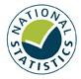

© Crown copyright 2019
This publication (not including logos) is licensed under the terms of the Open Government Licence v3.0 except where otherwise stated. Where we have identified any third party copyright information you will need to obtain permission from the copyright holders concerned.

To view this licence:
visit www.nationalarchives.gov.uk/doc/open-government-licence/version/3 email psi@nationalarchives.gsi.gov.uk
write to Information Policy Team, The National Archives, Kew, London, TW9 4DU

About this publication:
enquiries Children and Early Years Statistics, Data Insight and Statistics Division, Department for Education, Level 2 Riverside, Bishopsgate House, Feethams, Darlington, DL1 5QE
EarlyYears.STATISTICS@education.gov.uk https://www.gov.uk/government/statistics/announcements/provision-for-children-under-five-in- england-january-2019

Reference: [Provision for children under five in England: January 2019]

Follow us on Twitter:  @educationgovuk | Like us on Facebook: facebook.com/educationgovuk

